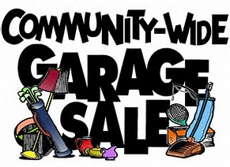

Roland Area City-Wide Garage Sale
Friday & Saturday
May 10 –May 11, 2023
If you’re interested in participating:
● Applications at Roland Public Library, City Hall,
or online at www.cityofroland.org
● Applications due no later than May 8, 2023
● Cost: $5.00
Clean out some clutter and gain some cash!!
Sign up today!

